Vendor performance project
Pizza sales sql queries
KPI’
1 . Total Revenue
SELECT SUM(total_price) AS Total_Revenue from pizza_sales
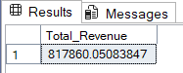

2. Average order Value
select sum(total_price) / COUNT (DISTINCT order_id) AS AVERAGE_ORDER_VALUE from pizza_sales
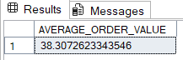

3 . Total pizza sold
select sum(quantity) AS Total_pizza_sold from pizza_sales
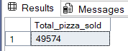

4. Total Orders
select count(Distinct order_id) AS Total_Orders from pizza_sales
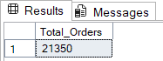

5 . Average pizzas per Order
Select SUM(quantity) / COUNT(DISTINCT order_id) AS Average_pizzas_per_order from pizza_sales
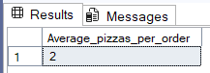

6. Daily Trend for Total Orders
select DATENAME(DW, order_date) as Order_Day, COUNT(DISTINCT order_id) AS Total_orders from pizza_sales
GROUP BY DATENAME(DW, order_date)
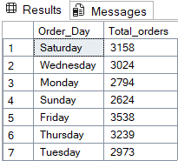

7. Monthly Trend for Total Orders
SELECT DATENAME(MONTH, order_date) AS Month_name, COUNT(DISTINCT order_id) AS Total_orders FROM pizza_sales
GROUP BY DATENAME(MONTH, order_date)
ORDER BY Total_orders DESC
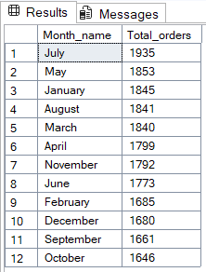

8. Percentage of sales by pizza category
SELECT pizza_category, CAST(SUM(total_price) AS DECIMAL(10,2)) as total_revenue,
CAST(SUM(total_price) * 100 / (SELECT SUM(total_price) from pizza_sales) AS DECIMAL(10,2)) AS PCT
FROM pizza_sales
GROUP BY pizza_category
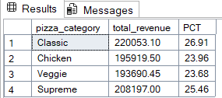

9. Percentage of sales by pizza size
SELECT pizza_size, CAST(SUM(total_price) AS DECIMAL(10,2)) as total_revenue,
CAST(SUM(total_price) * 100 / (SELECT SUM(total_price) from pizza_sales) AS DECIMAL(10,2)) AS PCT
FROM pizza_sales
GROUP BY pizza_size
ORDER BY pizza_size
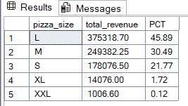

10. Total pizza sold by pizza category
SELECT pizza_category, SUM(quantity) as Total_Quantity_Sold
FROM pizza_sales
WHERE MONTH(order_date) = 2
GROUP BY pizza_category
ORDER BY Total_Quantity_Sold DESC

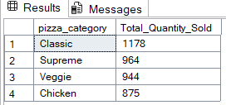

11. Top 5 pizzas by revenue
SELECT Top 5 pizza_name, SUM(total_price) AS Total_Revenue
FROM pizza_sales
GROUP BY pizza_name
ORDER BY Total_Revenue DESC
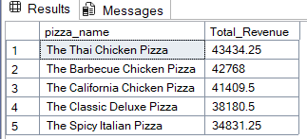

12. Bottom 5 pizzas by Quantity
SELECT Top 5 pizza_name, SUM(total_price) AS Total_Revenue
FROM pizza_sales
GROUP BY pizza_name
ORDER BY Total_Revenue ASC
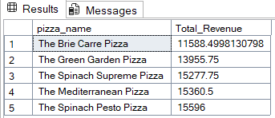

13. Top 5 pizzas by Total Orders
SELECT Top 5 pizza_name, COUNT(DISTINCT order_id) AS Total_Orders
FROM pizza_sales
GROUP BY pizza_name
ORDER BY Total_Orders DESC
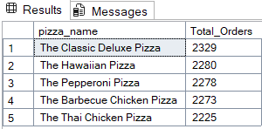

14. Bottom 5 pizzas by Total Orders
SELECT Top 5 pizza_name, COUNT(DISTINCT order_id) AS Total_Orders
FROM pizza_sales
GROUP BY pizza_name
ORDER BY Total_Orders ASC
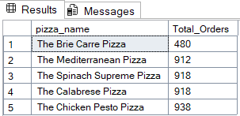

NOTE
If you want to apply the pizza_category or pizza_size filters to the above queries you can use WHERE clause. Follow some of below examples
SELECT Top 5 pizza_name, COUNT(DISTINCT order_id) AS Total_Orders
FROM pizza_sales
WHERE pizza_category = 'Classic'
GROUP BY pizza_name
ORDER BY Total_Orders ASC

